# Managing Medications

The Medications page allows the users to add, edit, and review medications prescribed for a patient. This includes:

* Prescribing a new medication
* Recording a medication
* Editing a medication
* Stopping a medication
* Reviewing the history of a medication

## How to Get Here

1. Search for the patient in the **Patients** menu, and select the patient from the list to open the patient dashboard.

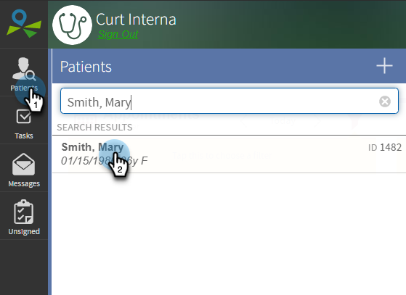

1. Click **Medications**.

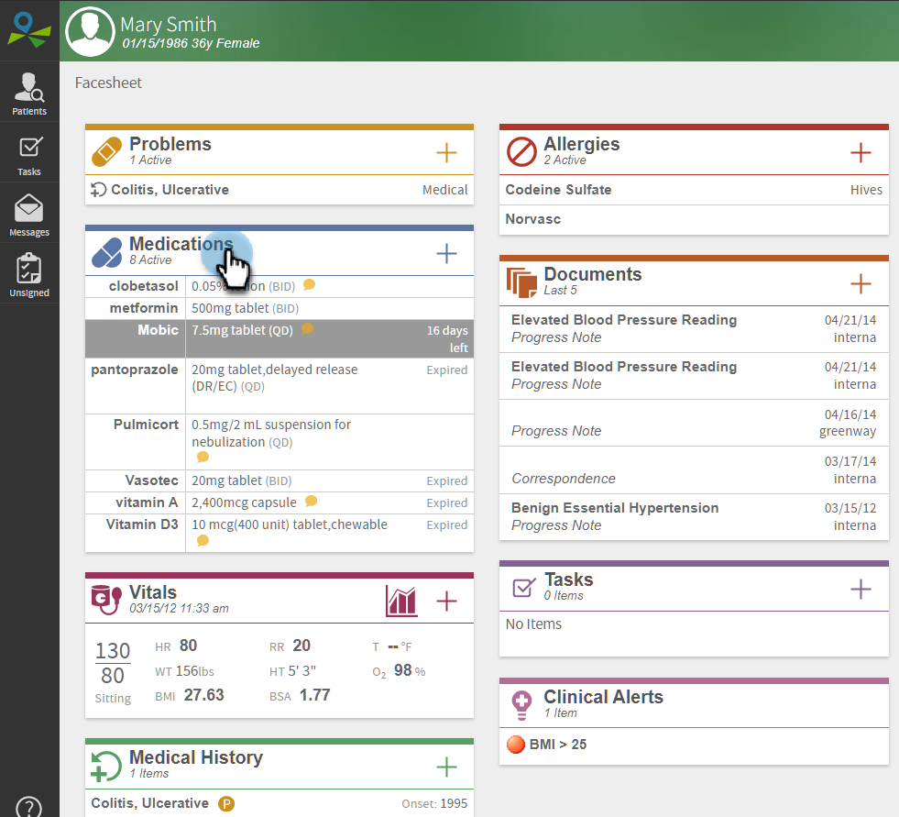

This opens the Medications page, where you can find all the active and discontinued medication data recorded against the selected patient.

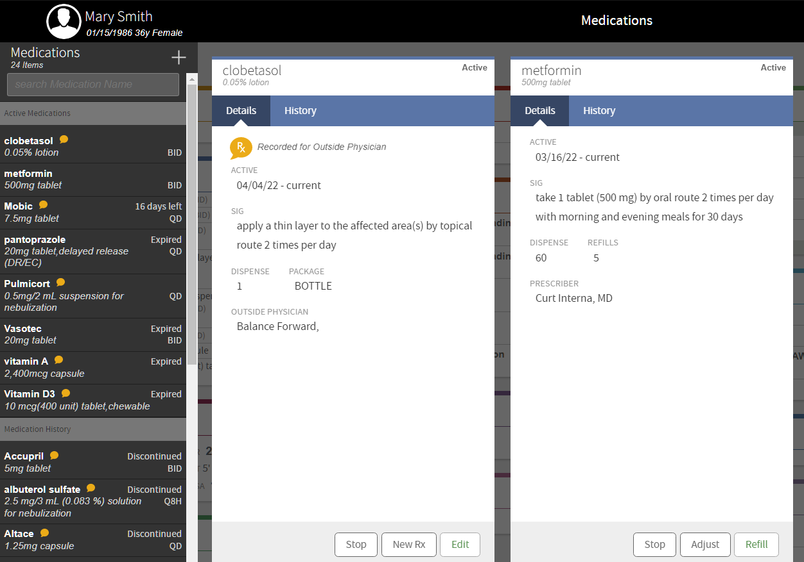

## Recording a Medication

1. Select the patient from the list.
2. Select **Medications**.
3. Click **+** and select **Record**. This opens the **New Recorded Medication** page.
4. Enter the following details:
   1. **INDICATION**: This defines the use and purpose of the medication. Search and choose the indication from the list.
   2. **MEDICATION**: This defines the name of the medication. Search and choose the drug from the list.
   3. **SIG**: This defines the directions for use of the medication, such as how and when to take the drug. You can create a custom sig under **CUSTOMIZE SIG** or select from the list of **COMMON SIGS**.
   4. **DURATION**: This defines the duration of the medication. Use the slider to set the days of use of the drug.
   5. **DISPENSE**: This defines the number of tablets to be provided to the patient. Use the slider to set the number of tablets to dispense.
   6. **REFILLS**: This defines the number of drug refills prescribed for the patient. Use the slider to set the number of refills.
   7. **EFFECTIVE**: This defines the date from which the medication is effective.
   8. **OPTIONS**: This defines the special nature of medication, if any. You can select if the drug is a maintenance drug, if a specific brand name is necessary, if samples are provided, and if the drug needs to be administered in the office.
   9. **PRESCRIBED BY**: This field defines the name of the primary care provider or phycisian.
   10. **COMMENTS**: This field defines any additional comments that are required in the medication record.

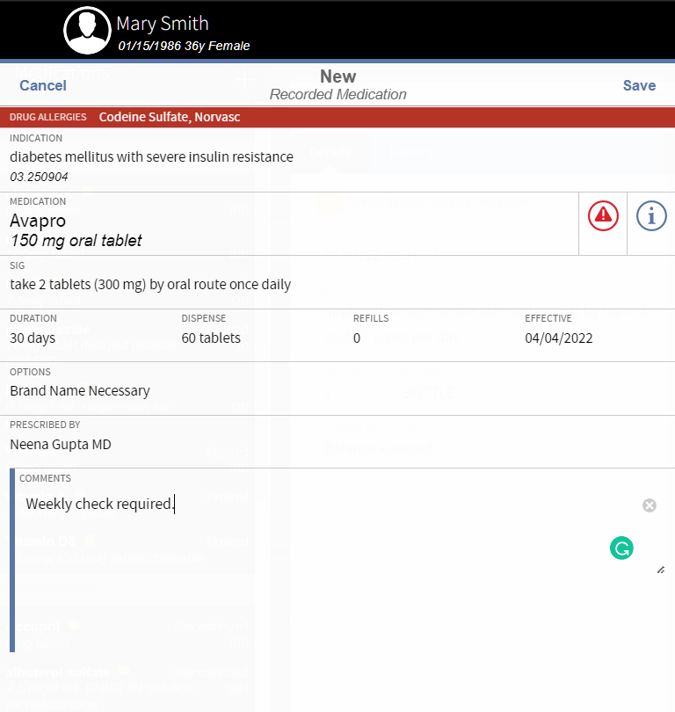

1. Select **Save**.

## Refilling a Medication

1. Select the patient from the list.
2. Select **Medications**.
3. Select **Refill** under the required medication.

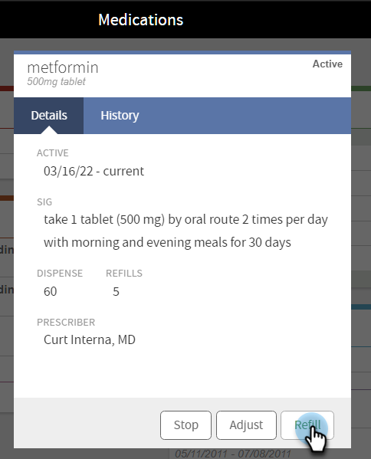

1. Enter the following details:
   1. **DURATION**: This defines the duration of the refilled medication. Use the slider to set the days of use of the drug.
   2. **DISPENSE**: This defines the number of tablets to be refilled for the patient. Use the slider to set the number of tablets to dispense.
   3. **REFILLS**: This defines the number of drug refills prescribed for the patient. Use the slider to set the number of refills.
   4. **EFFECTIVE**: This defines the date from which the refilled medication is effective.
2. Select **Prescribe**.

## Stopping a Medication

1. Select the patient from the list.
2. Select **Medications**.
3. Select **Stop** under the required medication.
4. Choose the reason for stopping the medication from the following:
   * **Discontinued by Patient**
   * **Discontinued by Provider**
   * **Prescription Completed**
   * **Entered in Error**

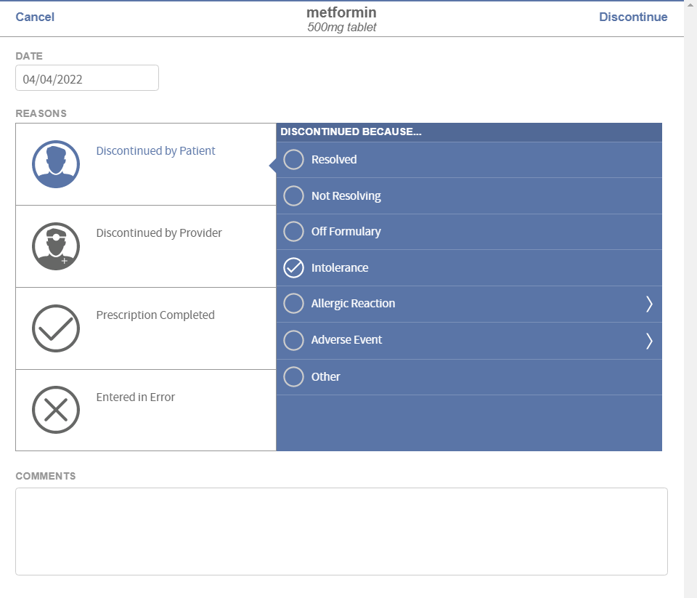

1. Add any additional comments, if any, under **COMMENTS**.
2. Select **Discontinue**.

# Health Information Exchange (HIE) and its importance in health care

The Health Information Exchange (HIE) replaces traditional forms of healthcare data management. The digital platforms of HIE completely avoids the dependency on offline data storage and eliminates the delay in communication. Instead, HIE’s online capabilities enable its users to instantly record, access, and analyse patient care data from anywhere at any time.

HIE digitalizes data organization and communication. All forms of patient information are stored in online databases. This includes consultation data and diagnosis, laboratory test results and medications, other patient care data and cautions, etc. With HIE, patients and care providers do not need to carry offline medical data on them. HIE store and standardize the data inside to make them readily available at the time of query.

HIE offers the following advantages to healthcare data management and communication:

* Improved speed of communication
* Improved accuracy of data
* Improved collaboration among care providers and technicians
* Improved availability of patient data
* Decreased duplications in tests and medications, etc.

**Interoperability**

HIE functions on the concept of interoperability. This means healthcare information systems can integrate and share information with each other to provide seamless availability of data. Medical professionals and caregivers across the globe can access this information and collaborate for the treatment. This also enables transfer of data from one point to another, such as when a patient approaches a different care centre or care provider.

There are three categories of information exchange in the healthcare industry:

* Directed exchange, in which care providers send and receive patient data from another healthcare professional. HIE uses encrypted channels of communication to serve the data to ensure security and privacy. This exchange is preferred between providers who know and trust each other.
* Query-based exchange, in which healthcare providers request for patient data during emergencies and similar unplanned care requirements. This exchange delivers all relevant and accessible information regarding the patient and their situation to the provider who requested the data.
* Consumer-mediated exchange, in which patients request and monitor their healthcare data for various purposes. This may include tracking of own health and medication, voluntary sharing of information with others including care providers, verifying billing information and insurance, etc.

In industries like healthcare, availability of reliable data is important. Unlike older days where patients and providers carried their health information on them or shared them over postal mails, advanced medicine require faster communication and easy access to information. This helps to ensure the best outcomes to treatment and maximum benefits to the patient. HIE helps to close the gap between complex healthcare infrastructure and patients in need. It improves the efficiency of healthcare systems with its enhanced speed of operation and sustained availability of data.